|  |  |
| --- | --- |
|  | |
| COA – ALL 240  ALL-240 – COA Screen at Voyage Level (hyperlink for Booking TEU and pop-up window)  Functional Specification | |
| Department: CMA CGM Commercial Allocation  Project: *DATAWAYS*  JIRA ID: ALL-240  Author(s): *Infosys* | |
| **Doc Reference:**  **Date:**  **Version:**  **Status:** | ALL-240 – COA Screen at Voyage Level (hyperlink for Booking TEU and pop-up window)  27.05.24  1.0  Draft To Be Reviewed |
| Classification: **Internal** | |

REVISIONS

|  |  |  |  |
| --- | --- | --- | --- |
| **Version** | **Date** | **Author** | **Subject** |
| 1.0 | 27-May-24 | Dinesh Maurya | Document creation |
| 1.1 | 4-June-24 | Dinesh Maurya | Additional Changes Required |

**REVIEWS**

|  |  |  |  |  |  |
| --- | --- | --- | --- | --- | --- |
| **Name** | **Title** | **Version** | **Date** | **Company** | **Signature** |
| Prabhu SESHADRI | IT Domain Lead | 1.0 |  | CMA CGM | Prabhu SESHADRI |
| HIENG Laurent | Product Owner | 1.0 |  | CMA CGM | HIENG Laurent |

APPROVALS

|  |  |  |  |  |  |
| --- | --- | --- | --- | --- | --- |
| **Name** | **Title** | **Version** | **Date** | **Company** | **Signature** |
| HOELLARD Damien | Lead Product Owner | 1.0 |  | CMA CGM | HOELLARD Damien |
| HIENG Laurent | Product Owner | 1.0 |  | CMA CGM | HIENG Laurent |

DISTRIBUTION LIST

|  |  |  |  |  |
| --- | --- | --- | --- | --- |
| **Name** | **Title** | **Company** | **To** | **Cc** |
| HOELLARD Damien | Lead Product Owner | CMA CGM | X |  |
| Prabhu SESHADRI | IT Domain Lead | CMA CGM | X |  |
| HIENG Laurent | Product Owner | CMA CGM | x |  |
| Veronique JOUSSELLIN | IT Domain Owner | CMA CGM |  | X |
| Julien D’ELIA | Enterprise Architect | CMA CGM |  | X |
| Youssef ATIK | Solution Architect | CMA CGM |  | X |
| Rudy MACARONUS | Chief Architect | CMA CGM |  | X |
| Victor BONY | Project Manager | CMA CGM |  | X |
| Ganesh IYER | Proxy Product Owner | Infosys |  | X |
| Ellina GALCHENKO | Product SME | Infosys |  | X |
| Akshita AHUJA | Product SME | Infosys |  | X |
| Dinesh Maurya | Product SME | Infosys |  | X |
| Savli TAPRE | Product SME | Infosys |  | X |
| Aishwarya RAJAN | UX Team | Infosys |  | X |
| Steffi SOLANKI | UX Team | Infosys |  | X |
| Abhishek KUMAR | Product SME | Infosys |  | X |
| Ben PAUL | Product SME | Infosys |  | X |
| Tameshwar SAHU | Solution Architect | Infosys |  | X |
| Tapas SARKAR | Solution Architect | Infosys |  | X |
| Bala Chami | Scrum Master | Infosys |  | X |
| Sinchu PANICKER | PMO | Infosys |  | X |

CONTENTS

1 - Requirements 5

1.1 Document References 5

1.2 New or Modified Objects 5

1.3 Acronyms & Glossary 6

2 - Detailed Design 6

2.1 Business Context and Scope: 6

2.2 Business Constraints or Assumptions 6

2.3 Functional Solution Risk 7

2.4 Requirement Details: 7

2.6 Process Flow and Domain Entities 8

2.7 UI / UX Design 8

2.8 Setups and configurations 16

2.9 Processing definition 16

2.10 Functional Test Cases 23

3 - Technical Details (Optional) 24

# - Requirements

|  |  |
| --- | --- |
| **Requirement ID** | **User Story / Requirement Description** |
| [ALL- 240](https://cmacgmgroup.sharepoint.com/:w:/r/sites/CMA-DataWays/_layouts/15/Doc.aspx?sourcedoc=%7B71121e66-5197-4a63-9a2d-6660f8d4a96a%7D&action=edit&wdPid=753abeac)- | ALL-240 – COA Screen at Voyage Level (hyperlink for Booking TEU and pop-up window) |

## 

### Document References

|  |  |  |  |  |
| --- | --- | --- | --- | --- |
| **Reference** | **Description** | **Version** | **Date** | **Author** |
| US ALL-238 | ALL 238 Display COA Screen at Voyage Level (Add Booking TEU, TONS, Unit columns in Allocation) | Jira | NA |  |
| US ALL-582 | Refresh/Relaunch bookings Consumption of COA | Jira | NA |  |

### New or Modified Objects

|  |  |
| --- | --- |
| **Components involved and purpose (Part of technical Document)** | |
| N/A |  |
|  |  |

### Acronyms & Glossary

|  |  |  |
| --- | --- | --- |
| **Term** | **Acronym** | **Definition** |
| Cargo Flow Bounds | Cargo Flow Bounds | A schedule bound is a segregation of a technical voyage into separate blocks that indicate the direction of the vessel sailing.  Schedule bounds have a 1:1 relation with a Commercial Voyage Number (CVN).  Schedule bound will be displayed as EB, WB, NB, SB and RT.  The same is shown as E = EB, WB, NB, SB in cargo flow bounds. |
| Service | Service | Service (Line) is a regular rotation operated by a group of vessels for a dedicated geographical corridor. |
| Service ID | Service ID | Service ID is a unique identifier associated with the Service. |
| Operational Restrictions | Operational Restrictions | Rules applied to the booking with the ability to define limitations for cargo or equipment types, including weight restrictions. |
| Port of Loading | POL | Port ID - It is the identification code given to every port. |
| Port of Departure | POD | Port ID - It is the identification code given to every port. |

# - Detailed Design

### Business Context and Scope:

This document covers the functionality of using the COA Screen at voyage level so that the user can check the detailed view of the Booking List (and download if available) from the Allocation Tab as a pop-up window. Here, the user can also identify all basic information needed for a voyage. The user will be able to click on a hyperlink on the column “Total Booked – TEU(s)” to view the Booking List.

### Business Constraints or Assumptions

* Cargo Flow Portal would be developed and accessible by all COA users.
* COA per Voyage and Sub-section will be available in the Cargo Flow Portal for all the authorized users.
* The system shall provide accurate and up-to-date reference data to populate the designated fields within the template.

**Note:** Roles and authorization will be covered in a separate user story ALL-139.

|  |
| --- |
| COA Screen at Voyage Level displays information inherited from a COA Template during the publish steps covered in below mentioned user stories: |
|  |
| * ALL- 221 COA - Automated Publish COA Template to Voyage (Back End) * ALL- 215 Cargo Flow Segmentation Back End Logic – Bound and CVN Determination. * ALL-208, ALL-543 Create COA Template (Maintain Operational Restrictions) * ALL-44 - Manually Publish COA Template to Voyage (Back End) * ALL-46 - Manually Publish COA Template to Voyage (Screen). |

### Functional Solution Risk

N/A

### Requirement Details:

As per the business requirement, an authorized user should be able to view details of Booking List on Allocation Tab on the column “Total Booked – TEU(s)” of the COA Screen at Voyage Level. When there are values, the user will be click on the booking value via a hyperlink and get the corresponding list with following **25** Tabs/Columns will appear on a pop-up window.

1. Booking Number.
2. Booking Date.
3. Booking Confirmation Date.
4. Reserved.
5. Booking Changed Date.
6. Service.
7. (CVN).
8. POL.
9. POD.
10. FPD.
11. Geo Trade Haul
12. Units.
13. TEU.
14. Weight (ton).
15. Reefer.
16. DG.
17. OOG.
18. BB.
19. Booking Agency.
20. Decidee.
21. Ultimate Owner.
22. ESR.
23. CSA rank
24. Cargo Ranking Score.
25. Broken

Once the authorized user updates all the mandatory fields and all the validation checks are done, the user can save the template.

### Process Flow and Domain Entities

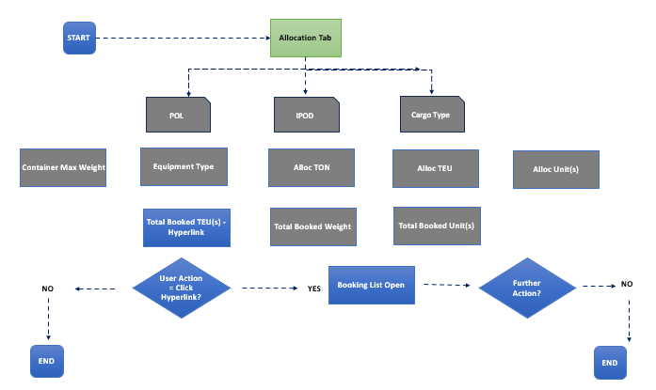

### UI / UX Design

**Please refer to the Figma file for the mock-ups:** Figma:  <https://www.figma.com/design/xy8DT97bl6eT0aOZUqAnsY/DATAWAYS-COA?node-id=4989-225042&t=wuZl7qtLIPLhUXnC-0>

1. Allocation Tab marked with red indicates the tab the user needs to be on to check Booking list. 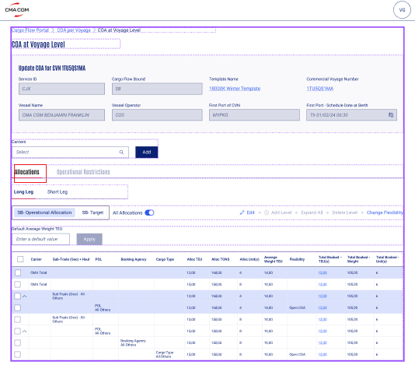
2. Field Column “Total Booked – TEU(s)” marked in red indicating where the user will be able to click on the booking value via a hyperlink (also marked in red).

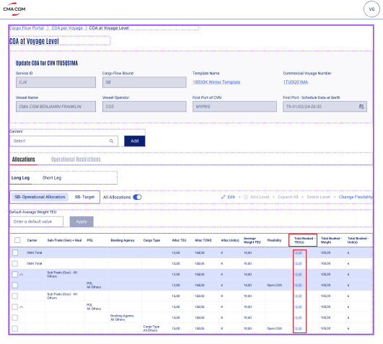

1. View of the Booking List if the field tab “Total Booked – TEU(s)” has value. The Booking list consists of **25** columns that will appear as pop-up window on the screen.
   1. Booking Number.
   2. Booking Date.
   3. Booking Confirmation Date.
   4. Reserved.
   5. Booking Changed Date.
   6. Service.
   7. (CVN).
   8. POL.
   9. POD.
   10. FPD.
   11. Geo Trade Haul
   12. Units.
   13. TEU.
   14. Weight (ton).
   15. Reefer.
   16. DG.
   17. OOG.
   18. BB.
   19. Booking Agency.
   20. Decidee.
   21. Ultimate Owner.
   22. ESR.
   23. CSA rank
   24. Cargo Ranking Score.
   25. Broken

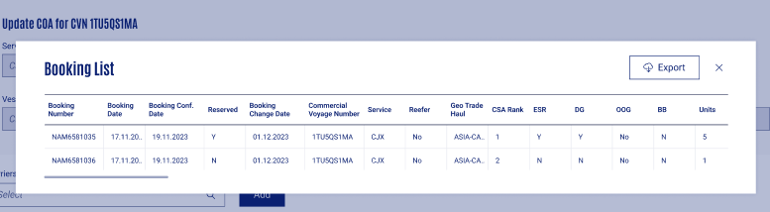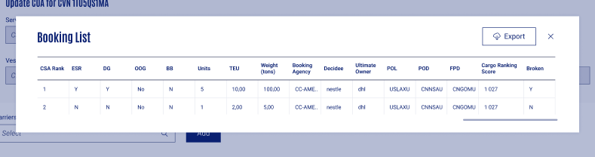

1. In case of no values from Booking the hyperlink will display are 0.00 in the field tab “Total Booked – TEU(s) marked in red.

1. The booking list pop-up window with message “No booking is available” if the user clicks on the hyperlink with zero values.

1. Booking list pop-up window with a cross button to close the window back, marked in red below.

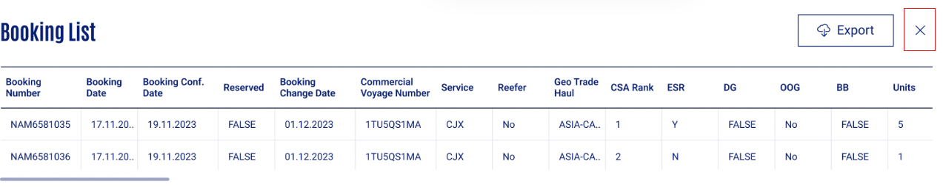

1. Export button on the Booking List pop-up window.

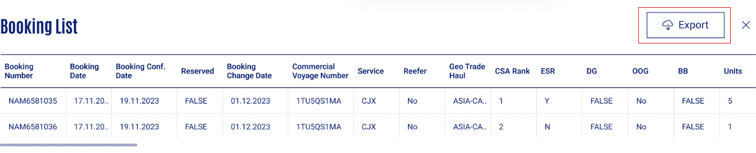

1. Confirmation message: “Bk List – 0FLD9W1MA – CARGO TYPE ALL OTHERS.xlsx exported” will appear at the top right corner of the screen. The file is downloaded in excel format.

**Validation and Rules**

Below are the detailed definitions for attributes, buttons, and error messages in search & display and editing boundary templates.

|  |  |  |  |  |  |  |  |
| --- | --- | --- | --- | --- | --- | --- | --- |
| **SR** | **Label or Fields** | **Description** | **F** | **A** | **D** | **List** | **Rules** |
| 1 | POL | Port of Loading to be selected by the user | FA | M | E |  |  |
| 2 | POD | Port of Departure to be selected by the user | FA | M | E |  |  |
| 3 | Cargo Type | Cargo Type to be selected by the user | LOV | M | E |  |  |
| 4 | Container Max Weight (metric tons) | Maximum weight allowed for container pertaining to the combination of POL-POD-Cargo Type to be added by the user.  Mandatory to fill value for ‘Container Max Weight’ in case user selects ‘Cargo Type-All Others’ | FN | O M | E D |  |  |
| 5 | Equipment Type | Type of equipment allowed to be selected by the user | LOV | O | E |  |  |
| 6 | Alloc TEU | Maximum TEU to be added by the user | FN | O | E |  |  |
| 7 | Alloc TONS | Maximum weight (in tons) to be added by the user | FN | O | E D |  |  |
| 8 | Alloc Unit(s) | Maximum allowed units to be added by the user | FN | O | E |  |  |
| 9 | Total Booked-TUE(s) | Total TEU(s) data retrieved from CFS **Ref Doc: ALL-238** | FN |  | E |  |  |
| 10 | Total Booked-Weight | Total Booked-Weight (in tons) data retrieved from CFS **Ref Doc: ALL-238** | FN |  | E |  |  |
| 11 | Total Booked-Unit(s) | Total Booked-Unit(s) data retrieved from CFS **Ref Doc: ALL-238** | FN |  | E |  |  |
| 9 | Edit | Edit button to be clicked by the user to make the table editable | BT |  | E |  |  |
| 10 | Add Level | Add Level button to be clicked by the user to add another row in the table | BT |  | D E |  |  |
| 11 | Delete Level | Delete Level button to be clicked by the user to delete a row in the table | BT |  | D E |  |  |
| 13 | Cancel | Cancel button to be clicked by the user to discard any changes made within the table | BT |  | E |  |  |
| 14 | Save | Save button to be clicked by the user to save the table and move from editable to un-editable mode. | BT |  | E |  |  |
| 15 | DG | Dangerous Goods - A dangerous goods container is a type of outdoor chemical storage unit. |  |  | E |  |  |
| 16 | OOG | Out of Gauge - Any cargo that cannot be loaded into six-sided shipping containers due to its size. |  |  | E |  |  |
| 17 | BB | Break Bulk - Liner transport with stable shipping schedule |  |  | E |  |  |
| 18 | FPD | Final Place of Delivery |  |  | E |  |  |
| 19 | ESR | Extra Space Required |  |  | E |  |  |

**Legend**

|  |  |  |  |  |  |  |  |  |
| --- | --- | --- | --- | --- | --- | --- | --- | --- |
| Format | CB | Check Box | Attribute | M | Mandatory | Display | D | Field disabled |
| FA | Field alpha | O | Optional | E | Field Enabled |
| FN | Field numeric |  |  | R | Read Only |
| LOV | List of Value |  |  | H | Hidden |
| DA | Date |  |  |  |  |
| BT | Button |  |  |  |  |
| DT | Date Time |  |  |  |  |

### Setups and configurations

Not Available

### Processing definition

Following business rules must be implemented:

|  |  |
| --- | --- |
| **ALL- 240** | |
| **ALL-240 – COA Screen at Voyage Level (hyperlink for Booking TEU and pop-up window)** | |
| **BR01** | **The user will land on the Allocation tab of COA Screen at Voyage Level** |
| **BR02** | **Focus area for the user on the Allocation Tab is “Total Booked – TEU(s)” (CF ALL 238).** The values in the “Total Booked – TEU(s)” column are highlighted with a hyperlink which the user can click to check the booking list. |
| **BR03** | **The user clicks on the hyperlink on the “Total Booked – TEU(s)” column to check the Booking List** |
| **BR04** | **The Booking list will appear as a pop-up window consisting of 25 columns for the user.**   1. Booking Number. 2. Booking Date. 3. Booking Confirmation Date. 4. Reserved. 5. Booking Changed Date. 6. Service. 7. (CVN). 8. POL. 9. POD. 10. FPD. 11. Geo Trade Haul 12. Units. 13. TEU. 14. Weight (ton). 15. Reefer. 16. DG. 17. OOG. 18. BB. 19. Booking Agency. 20. Decidee. 21. Ultimate Owner. 22. ESR. 23. CSA rank 24. Cargo Ranking Score. 25. Broken       Note: The user can use the scroll option toggle from left to right to get full view of the Booking list |
| **BR05** | **The user will get the corresponding booking list with the following columns (as a pop-up windows) with value example and data source shown below. (**Ref US ALL-240)   |  |  |  | | --- | --- | --- | | **Value name** | **Value Example** | **Source** | | **Booking Number** | **NAM6581035** | LARA | | **Booking Date** | **17/11/2023** | LARA | | **Booking Conf. Date** | **19/11/2023** | LARA | | **Reserved** | **Y/N** | LARA | | **Booking Change Date**  **(1)** | **01/12/2023** | LARA | | **Service** | **FAL 1** | Schedule | | **Commercial Voyage Number** | **0FLB9W1MA** | Schedule (ops cvn) | | **POL** | **USLAX** | LARA | | **POD** | **CNNSA** | LARA | | **FPD** | **CNGOM** | LARA | | **Geo Trade haul** | **ASIA - CAR/ECCA/NCSA ; H.H** | API Source application will be MY CDM- Data object “ geocom Trade/sub-trade/haul” | | **Units** | **1** | LARA | | **TEU** | **2** | LARA | | **Weight ( tons)** | **20,25** | LARA | | **Reefer** | **Yes** | LARA | | **DG** | **Yes** | LARA | | **OOG** | **No** | LARA | | **BB** | **yes** | LARA | | **Booking Agency** | **CC AMERICA** | cargo flow referential | | **Decidee** | **nestle** | LARA | | **Ultimate Owner** | **dhl** | My cdm | | **ESR** | **YES/NO** | LARA | | **Csa Rank** | **1** | LARA | | **Cargo Ranking Score** | **1 027** | Dataways api | | **Broken** | **YES/NO** | Dataways api | |
| **BR06** | All dates should be translated in DataWays into the format as follows: DD.MM.YYYY |
| **BR07** | **Booking change** **date:** only reflects changes in booking in Lara of only TEU, Weight or Plugs values. All other changes from Lara in Booking should not be considered**.** |
| **BR08** | **The user will have the option to close the booking list pop-up** window by clicking on the cross button on the top right corner. |
| **BR09** | **The user can click on the “Export” to download values in an excel file**.  *Note: This excel should ONLY contain values of the specific level of Booking List that has been clicked open* |
| **BR10** | **The user will see the confirmation message once the file is downloaded in excel.** Confirmation Message: “Bk List – 0FLD9W1MA – CARGO TYPE ALL OTHERS exported.”   |
| **BR11** | In case of no value from Booking, the hyperlink is available, and the value will show “0.00”, but the pop-up windows will be open with the mention “No booking is available |
| **BR12** | CSA Rank display will follow the same rule than AC -10 from **ALL-568 Display - COA Screen at Voyage Level - COA Screen at Voyage Level (Add Booking TEU per CSA ranks expandable columns in Allocation)** |
| *Note:* | *Value inside to be refreshed when relaunch consumption is triggered (rules for relaunch consumption will be detailed on US ALL 582 Refresh/Relaunch bookings Consumption of COA)* |

### Functional Test Cases

|  |  |  |  |
| --- | --- | --- | --- |
| **Test Case #** | **Rule** | **Functional Test** | **Expected Results** |
| **ALL-240 COA- Screen at Voyage Level (Edit Allocation Value in Operational Restrictions)** | | | |
| **TC1** |  | Check whether all the elements on the Operational Restrictions screen matches with the UX/UI Mock-ups | Refer section 2.6 UX/UI Designs. |
| **TC2** | BR02 | The user on the COA screen at Voyage can access Allocation Tab | The Allocation Tab is enabled for the user. |
| **TC3** | BR03 | The user tries to click on the hyperlink | The hyperlink is enabled. |
| **TC4** | BR03 | The user tries clicks on the hyperlink with values on Total Booked TEU(s) | The hyperlink opens a pop-window to details Booking List. |
| **TC5** | BR04 | The user can view all the columns on Booking list | The user will find 22 relevant columns. |
| **TC6** | BR06 | The data flow on the Booking List | Ensure relevant data source for correct information e.g. LARA, CF, MYcdm . |
|  | | | |
| **TC7** | BR08 | The user can cancel the pop-up window | Enable cancel button to collapse the booking list window when the user clicks on it. |
| **TC8** | BR11 | The user tries clicks on the hyperlink with ‘no values’ on Total Booked TEU(s) | The hyperlink opens a pop-window with a message ‘No booking is available’. |
| **TC9** | BR10 | The user clicks on export button | Enables user button so the user can download the data in an excel format. |

# - Technical Details (Optional)

Technical solution will be done by architect and development teams.

- End of document –